**Connect Four**

http://www.cs.hmc.edu/courses/2003/fall/cs5/week_10/c4.gif

The game is played by two players, alternating turns, with each trying to place four checkers in a row vertically, horizontally, or diagonally. One constraint in the game is that because the board stands vertically, the checkers cannot be placed into an arbitrary position. A checker may only be placed at the top of one of the currently existing columns (or it may start a new column).

In this problem, you will need to create a class named Board that implements some of the features of the Connect Four game. The Board class will have three data members: there will be a two-dimensional list (a list of lists) containing characters to represent the game area, and a pair of variables holding the number of rows and columns on the board (6 rows and 7 columns is standard), but your Board data type will be able to handle boards of any size.

Even as we allow arbitrary board sizes, however, we will preserve the four-in-a-row requirement for winning the game. Admittedly, this makes it hard to win the game on a 3x3 board.

Your task is to write the Board class. Details appear here:

**The** Board **class**

Your Board class should have at least three data members:

* A variable data storing the two-dimensional array (list of lists),   
  which is the game board
* A variable height storing the number of rows on the game board
* A variable width storing the number of columns on the game board

Note that the two-dimensional list is a two-dimensional list of *characters*, which are just strings of length 1. You should represent an empty slot by ' ', which is the space character -- not the empty string. You should represent player X's checkers with an 'X' (the capital x character) and you should represent player O's checkers with an 'O' (the capital o character).

**Warning!**  
A **very** difficult bug to find occurs if you use the ***zero*** '0' character instead of the 'O' character (capital-O) to represent one of the players. The problem occurs when you start comparing values in the board with the wrong one! Be sure to stay consistent with the capital-O character.

**Methods required for the** Board **class**

You should provide your Board class with the following methods.

Be sure to try the hints on how to test each one after writing it!

The first two methods are provided for copy-and-paste, below.

**__init__**, the constructor

* __init__(self, width, height):  
    
  This is a constructor for Board objects that takes two arguments. (Remember that self refers to the object being constructed and that it is not explicitly passed into the constructor.) This constructor takes in a number of columns and rows (7 and 6 are the connect-four standard, but our data type will handle arbitrarily-sized boards). The constructor will set the values of the data members of the object.   
  In addition, it will initialize the two-dimensional list representing the board.   
    
  Note that you don't want self.data to contain all of the characters that go into printing the board -- only the ones that affect the play of the game.   
  The extra characters will be generated in the __repr__ method.

**__repr__**, for printing or any string representation

* __repr__(self):  
    
  This method returns a string representing the Board object that calls it. Basically, each "checker" takes up one space, and all columns are separated by vertical bars (|). The columns are labeled at the bottom. Here is an example for a 6-row and   
  7-column (6x7) board (see the code below for details.)

| | | | | | | |

| | | | | | | |

| | | | | | | |

| | | | | | | |

| | | | | | | |

| | | | | | | |

---------------

0 1 2 3 4 5 6

In order to keep things in line, the column-numbering should be done "mod 10," as this larger 5-row, 15-column (5x15) example shows:

| | | | | | | | | | | | | | | |

| | | | | | | | | | | | | | | |

| | | | | | | | | | | | | | | |

| | | | | | | | | | | | | | | |

| | | | | | | | | | | | | | | |

-------------------------------

0 1 2 3 4 5 6 7 8 9 0 1 2 3 4

**The code to start with...**  
Here is the code to start with -- ***remember that you will need to get rid of the magic numbers*** (7 columns and 6 rows) as you generalize this code to have width columns and height rows.

class Board:

""" a datatype representing a C4 board

with an arbitrary number of rows and cols

"""

def __init__( self, width, height ):

""" the constructor for objects of type Board """

self.width = width

self.height = height

W = self.width

H = self.height

self.data = [ [' ']*W for row in range(H) ]

# we do not need to return inside a constructor!

def __repr__(self):

""" this method returns a string representation

for an object of type Board

"""

H = self.height

W = self.width

s = '' # the string to return

for row in range(0,H):

s += '|'

for col in range(0,W):

s += self.data[row][col] + '|'

s += '\n'

s += (2*W+1) * '-' # bottom of the board

# TODO - the numbers underneath here

return s # the board is complete, return it

Next, implement the following methods in your Board class.

Be sure to test each one after you write it.

**addMove**, for dropping a checker into the board

* addMove(self, col, ox):   
    
  This method takes two inputs: the first input col represents the index of the column to which the checker will be added; the second input ox will be a   
  1-character string representing the checker to add to the board.  
  That is, ox should either be 'X' or 'O' (again, capital O, not zero).

*Remember that the checker slides down from the top of the board!* Thus, your code will have to find the appropriate row number available in column col and put the checker in that row. In addMove you do **not** have to check that col is a legal column number or that there is space in column col. That checking is important, however. The next method, which is called allowsMove, will do just that.   
  
Testing addMove  
Here is a sequence for testing addMove -- try it out!

b = Board(7,6)

b.addMove(0, 'X')

b.addMove(0, 'O')

b.addMove(0, 'X')

b.addMove(3, 'O')

b.addMove(4, 'O') # cheating by letting O go again!

b.addMove(5, 'O')

b.addMove(6, 'O')

print b

| | | | | | | |

| | | | | | | |

| | | | | | | |

|X| | | | | | |

|O| | | | | | |

|X| | |O|O|O|O|

---------------

0 1 2 3 4 5 6

**clear( self )**, should clear the board that calls it.

Not much to say about clear( self ). It's useful, though!

**setBoard**, for applying *many* moves to a board

This one is really useful for quickly creating a board to test your winsFor in the next part. Here is the code we used for setBoard - you should include this in your Board class, because it makes testing much easier!

def setBoard( self, moveString ):

""" takes in a string of columns and places

alternating checkers in those columns,

starting with 'X'

For example, call b.setBoard('012345')

to see 'X's and 'O's alternate on the

bottom row, or b.setBoard('000000') to

see them alternate in the left column.

moveString must be a string of integers

"""

nextCh = 'X' # start by playing 'X'

for colString in moveString:

col = int(colString)

if 0 <= col <= self.width-1:

self.addMove(col, nextCh)

if nextCh == 'X': nextCh = 'O'

else: nextCh = 'X'

**allowsMove**, for checking if a column is a legal move

* allowsMove(self, c):  
    
  This method should return True if the calling object (of type Board) **does** allow a move into column c. It returns False if column c is not a legal column number for the calling object. It also returns False if column c is full. Thus, this method should check to be sure that c is within the range from 0 to the last column *and* make sure that there is still room left in the column!

Testing allowsMove  
Here is an example sequence for testing -- try it!

>>> b = Board(2,2)

>>> b

| | |

| | |

-----

0 1

>>> b.addMove(0, 'X')

>>> b.addMove(0, 'O')

>>> b

|O| |

|X| |

-----

0 1

>>> b.allowsMove(-1)

False

>>> b.allowsMove(0)

False

>>> b.allowsMove(1)

True

>>> b.allowsMove(2)

False

**isFull**, checks if the board is full

* isFull(self):  
    
  This method should return True if the calling object (of type Board) is completely full of checkers. It should return False otherwise. Notice that you can leverage allowsMove or make this method very concise! Unless you're supernaturally patient, you'll want to test this on small boards:

Testing isFull  
Here is an example sequence for testing (it uses setBoard, above)...

>>> b = Board(2,2)

>>> b.isFull()

False

>>> b.setBoard( '0011' )

>>> b

|O|O|

|X|X|

-----

0 1

>>> b.isFull()

True

**delMove**, removes a checker from the board

* delMove(self, c):   
    
  This method should do the opposite of addMove. It should remove the top checker from the column c. If the column is empty, then delMove should do nothing. This function may not seem useful now, but it will become *very* useful when you try to implement your own Connect Four player.

Testing delMove  
Here is an example sequence for testing:

>>> b = Board(2,2)

>>> b.setBoard( '0011' )

>>> b.delMove(1)

>>> b.delMove(1)

>>> b.delMove(1)

>>> b.delMove(0)

>>> b

| | |

|X| |

-----

0 1

**winsFor**, checks if someone has won the game

* winsFor(self, ox): This method's input ox is a 1-character checker: either 'X' or 'O'. It should return True if there are four checkers of type ox in a row on the board.   
  It should return False othwerwise.   
  **Important Note:** you need to check if the player has won horizontally, vertically, or diagonally (and there are two different directions for a diagonal win).   
    
  One way to approach this is to consider each possible *anchor* checker that might start a four-in-a-row run. For example, all of the "anchors" that might start a horizontal run (going from left to right) must be in the columns *at least four places from the end of the board*. That constraint will help you avoid out-of-bounds errors. Here is some starter code that illustrates this technique (but as of yet only checks for horizontal wins):

H = self.height

W = self.width

D = self.data

# check for horizontal wins

for row in range(0,H):

for col in range(0,W-3):

if D[row][col] == ox and \

D[row][col+1] == ox and \

D[row][col+2] == ox and \

D[row][col+3] == ox:

return True

Note the backslash characters -- these tell Python that the line of code will continue on the next line of the file.

Note, too, the -3 that keeps the checking in bounds.   
Different directions will require different guards against going out of bounds.

**Warning**It's better *not* to explicitly *count* checkers to see if you reach four. The problem is that you must visit each checker in the right order. Vertical and horizontal orderings aren't bad, but visiting each checker in diagonal order is neither easy nor informative. It's more convenient to check for all four checkers at once, as in the previous example.

This is an important method to test thoroughly! Here are a few tests to get you started:

Testing winsFor:  
Here is an example sequence for testing:

>>> b = Board(7,6)

>>> b.setBoard( '00102030' )

>>> b.winsFor('X')

True

>>> b.winsFor('O')

True

>>> b = Board(7,6)

>>> b.setBoard( '23344545515' )

>>> b

| | | | | | | |

| | | | | | | |

| | | | | |X| |

| | | | |X|X| |

| | | |X|X|O| |

| |O|X|O|O|O| |

---------------

0 1 2 3 4 5 6

>>> b.winsFor('X') # diagonal

True

>>> b.winsFor('O')

False

**hostGame**, hosts a full game of Connect Four

* hostGame(self): This method brings everything together into the familiar game.   
  It should host a game of connect four, using the methods listed above to do so.   
  In particular, it should alternate turns between 'X'(who will always go first) and 'O' (who will always go second). It should ask the user (with the input function) to select a column number for each move. See below for an example of how the interaction should work, but here are a few important points to keep in mind:
  + This method should print the board before prompting for each move.
  + You will probably want to use a large while loop to structure the game. You should have 'X' go first and 'O' go second. My suggestion would be to put both 'X's and 'O's turn into the body of the while loop. Thus, one iteration of the while loop will make two connect-four turns.
  + You might also use the infinite loop while True: and then use break when the game ends somewhere in the loop's body.
* After each input, you should check if the column chosen is a valid one. Thus, this method should detect illegal moves, either out-of-bounds or a full column, and prompt for another move instead. You do not have to check if the input is an integer, however; you may assume it will always be one. So, do use input instead of raw_input.
* As a guide to how you might handle the case when a user inputs an *incorrect* move, consider the following small loop:

users_col = -1

while self.allowsMove( users_col ) == False:

users_col = input("Choose a column: ")

The above code will simply continue to prompt the user for a column number that is valid until it receives one.

* This hostGame method should place each checker into the user's chosen (valid!) column. Then, it should check if that player has won the game or if the board is now full.
* If the game is over for either reason, the game should stop, the board should be printed out one last time, and the program should report who won (or that it was a tie.) Note that you can use break to get out of a loop -- even if that break is within an if/else statement.
* If the game is not over, the other player should be prompted to make a move, and so on...

Be sure to test this method by playing the game a few times (with each possible ending)!

Here is an example run, to give a sense of the input and output:

>>> b = Board(7,6)

>>> b.hostGame()

Welcome to Connect Four!

| | | | | | | |

| | | | | | | |

| | | | | | | |

| | | | | | | |

| | | | | | | |

| | | | | | | |

---------------

0 1 2 3 4 5 6

X's choice: 3

| | | | | | | |

| | | | | | | |

| | | | | | | |

| | | | | | | |

| | | | | | | |

| | | |X| | | |

---------------

0 1 2 3 4 5 6

O's choice: 4

| | | | | | | |

| | | | | | | |

| | | | | | | |

| | | | | | | |

| | | | | | | |

| | | |X|O| | |

---------------

0 1 2 3 4 5 6

X's choice: 2

| | | | | | | |

| | | | | | | |

| | | | | | | |

| | | | | | | |

| | | | | | | |

| | |X|X|O| | |

---------------

0 1 2 3 4 5 6

O's choice: 4

| | | | | | | |

| | | | | | | |

| | | | | | | |

| | | | | | | |

| | | | |O| | |

| | |X|X|O| | |

---------------

0 1 2 3 4 5 6

X's choice: 1

| | | | | | | |

| | | | | | | |

| | | | | | | |

| | | | | | | |

| | | | |O| | |

| |X|X|X|O| | |

---------------

0 1 2 3 4 5 6

O's choice: 2

| | | | | | | |

| | | | | | | |

| | | | | | | |

| | | | | | | |

| | |O| |O| | |

| |X|X|X|O| | |

---------------

0 1 2 3 4 5 6

X's choice: 0

X wins -- Congratulations!

| | | | | | | |

| | | | | | | |

| | | | | | | |

| | | | | | | |

| | |O| |O| | |

|X|X|X|X|O| | |

---------------

0 1 2 3 4 5 6

>>>

**Graphical Connect Four**

Use the graphics.py object-oriented Python graphics package in order to provide a graphical front-end to your Connect Four Board class.

[Use a starter file, graphicsForC4.zip, with an example of how to create a graphical board](http://www.cs.hmc.edu/~cs5grad/cs5/graphicsForC4.zip).

Here is an image of how to run that example:

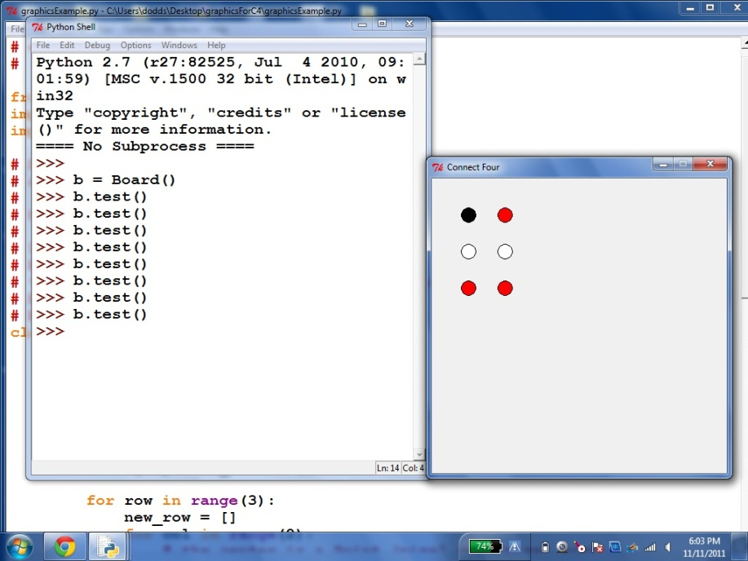

There are plenty of details to work out, even with this example, however!

Use the graphics window for input (via mouse clicks), too.

In this case, you'll want to look up the documentation for this graphics.py library: it's at

<http://mcsp.wartburg.edu/zelle/python/graphics/graphics/index.html>